## TEST STATISTICS

|  |  |
| --- | --- |
| User Name: ……………………………………………. | Trainer Name: Ruchira Ariyasinghe |
| User Sign. : ……………………………………………. | Trainer Sign. : ……………………………………………. |

**TEST STATISTICS**

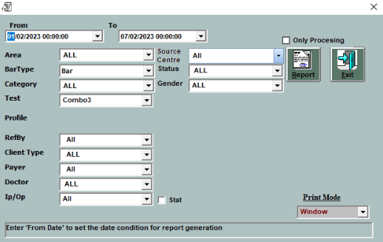

#### Go to Account main menu and select Test Statistics.

* Select the date criteria
* Select the Area like system
* Select the Bar type to get different type of graph.
* Select the category.
* Select the test to particular test report.

